Documentation –

Training Karyawan

REST API with GIN Framework

shabrinur @ github

Simple REST API module for CRUD with PostgreSQL.

# Karyawan API

## Create Karyawan

Create record of **karyawan** based on request body.

curl -L -X POST 'http://localhost:8080/v1/idstar/karyawan/save' \

-H 'Content-Type: application/json' \

--data-raw '{

    "dob": "{{Tanggal lahir karyawan YYYY-MM-DD}}",

    "nama": "{{Nama karyawan}}",

    "status": "{{Status active/inactive}}",

    "alamat": "{{Alamat karyawan}}",

    "detailKaryawan": {

        "nik": "{{NIK karyawan}}",

        "npwp": "{{NPWP karyawan}}"

    }

}'

**Sample request:**

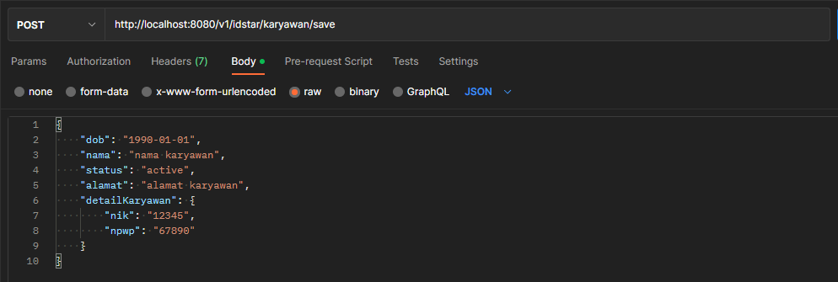

**Sample response:**

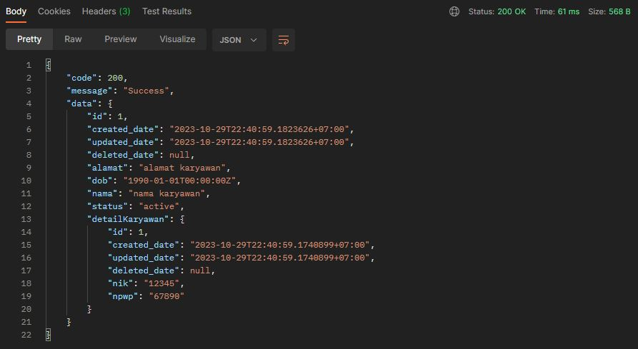

## Update Karyawan

Update record of **karyawan** based on request body.

curl -L -X PUT 'http://localhost:8080/v1/idstar/karyawan/update' \

-H 'Content-Type: application/json' \

--data-raw '{

    "id": {{ID karyawan numerik}},

    "dob": "{{Update tanggal lahir karyawan YYYY-MM-DD}}",

    "nama": "{{Update nama karyawan}}",

    "status": "{{Update status active/inactive}}",

    "alamat": "{{Update alamat karyawan}}",

    "detailKaryawan": {

        "id": {{ID karyawan numerik}},

        "nik": "{{Update NIK karyawan}}",

        "npwp": "{{Update NPWP karyawan}}"

    }

}'

**Sample request:**

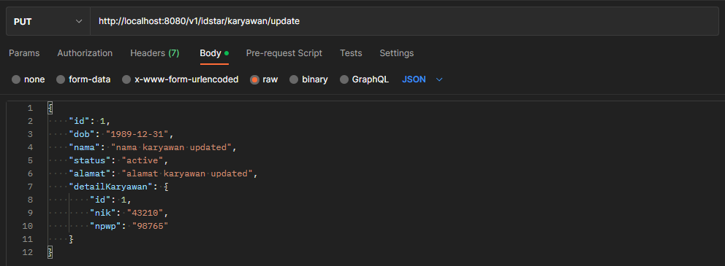

**Sample response:**

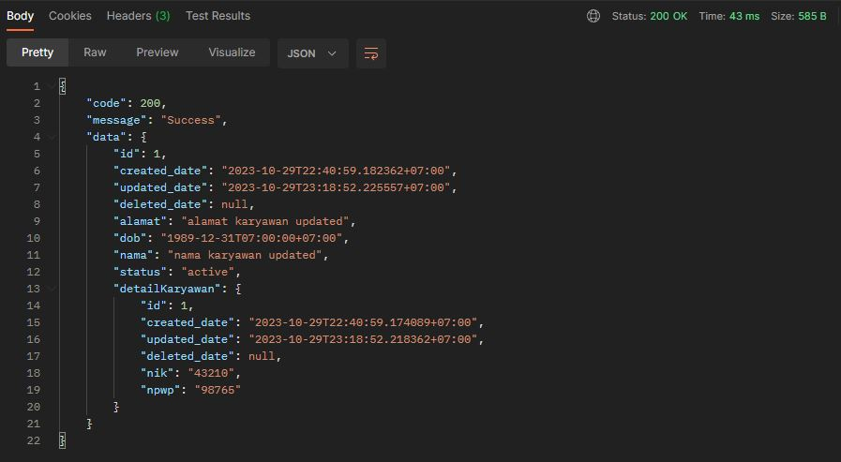

## Get Karyawan List

Get list of **karyawan** with paging and sorting.

Paging and sorting specification can be sent through **form-data** or **query parameter**.

curl -L -X GET 'http://localhost:8080/v1/idstar/karyawan/list' \

-F 'page="{{Nomor paging}}"' \

-F 'size="{{Jumlah record di 1 page}}"' \

-F 'field="{{Field sorting}}"' \

-F 'direction="{{Arah sorting asc/desc}}"'

curl -L -g -X GET 'http://localhost:8080/v1/idstar/karyawan/list?page={{Nomor paging}}&size={{Jumlah record di 1 page}}&field={{Field sorting}}&direction={{Arah sorting asc/desc}}'

**Sample request:**

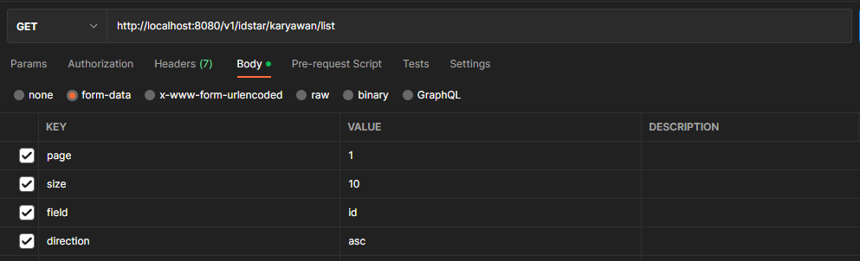

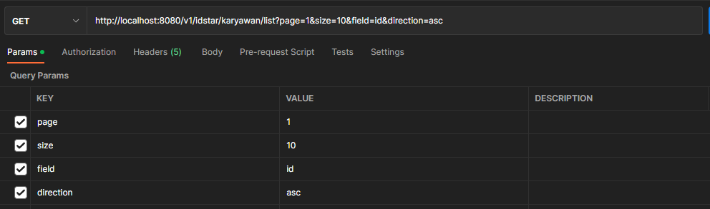

**Sample response:**

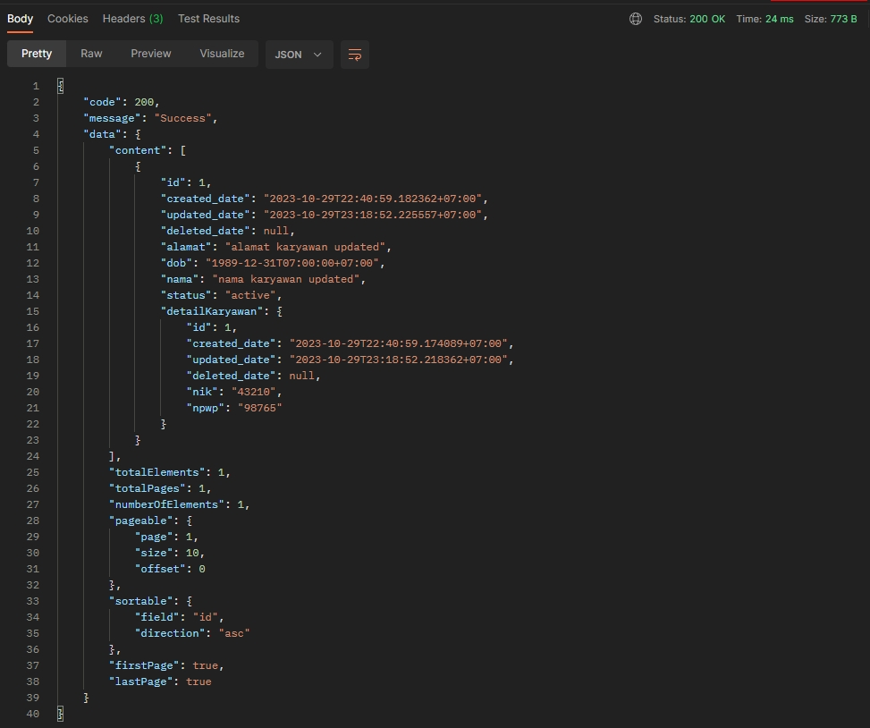

## Get Karyawan By ID

Get one **karyawan** record by **ID**.

curl -L -g -X GET 'http://localhost:8080/v1/idstar/karyawan/{{ID karyawan numerik}}'

**Sample request:**

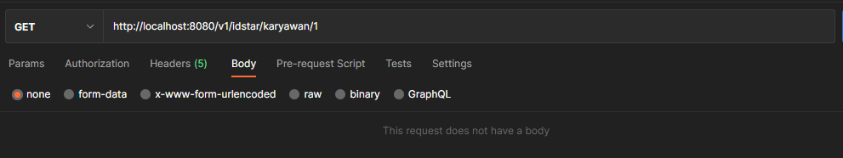

**Sample response:**

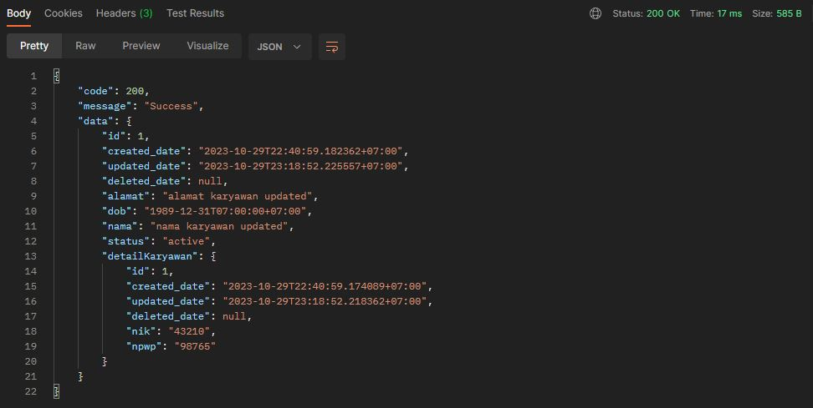

## Delete Karyawan

Delete one **karyawan** record by **ID**.

curl -L -X DELETE 'http://localhost:8080/v1/idstar/karyawan/delete' \

-H 'Content-Type: application/json' \

--data-raw '{

    "id": {{ID karyawan numerik}}

}'

**Sample request:**

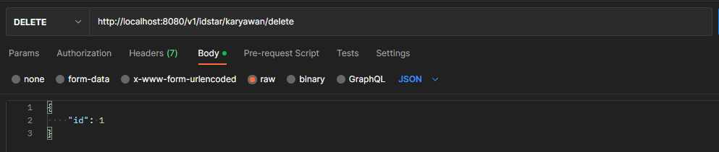

**Sample response:**

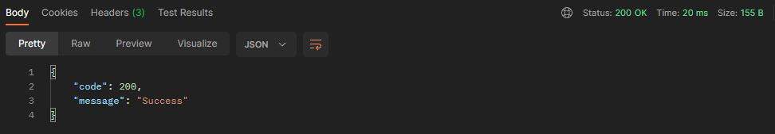

# Rekening API

## Create Rekening

Create record of **rekening** based on request body.

curl -L -X POST 'http://localhost:8080/v1/idstar/rekening/save' \

-H 'Content-Type: application/json' \

--data-raw '{

    "jenis": "{{Jenis rekening}}",

    "nama": "{{Nama pemilik rekening}}",

    "rekening": "{{Nomor rekening}}",

    "karyawan": {

        "id": {{ID karyawan numerik}}

    }

}'

**Sample request:**

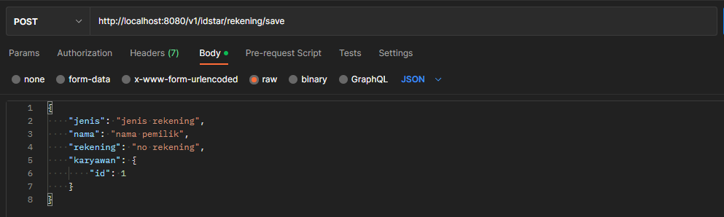

**Sample response:**

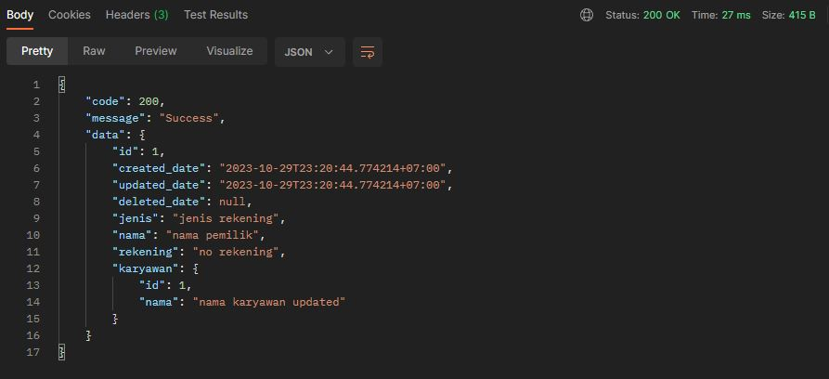

## Update Rekening

Update record of **rekening** based on request body.

curl -L -X PUT 'http://localhost:8080/v1/idstar/rekening/update' \

-H 'Content-Type: application/json' \

--data-raw '{

    "id": {{ID rekening numerik}},

    "jenis": "{{Update jenis rekening}}",

    "nama": "{{Update pemilik rekening}}",

    "rekening": "{{Update nomor rekening}}",

    "karyawan": {

        "id": {{ID karyawan numerik}}

    }

}'

**Sample request:**

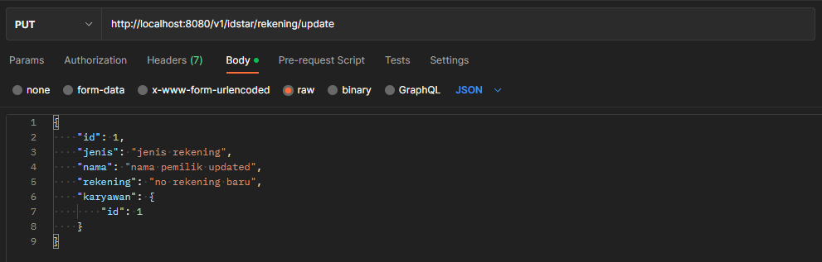

**Sample response:**

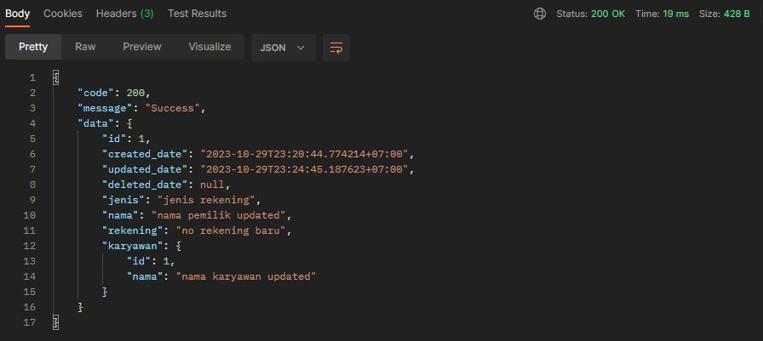

## Get Rekening List

Get list of **rekening** with paging and sorting.

Paging and sorting specification can be sent through **form-data** or **query parameter**.

curl -L -X GET 'http://localhost:8080/v1/idstar/rekening/list' \

-F 'page="{{Nomor paging}}"' \

-F 'size="{{Jumlah record di 1 page}}"' \

-F 'field="{{Field sorting}}"' \

-F 'direction="{{Arah sorting asc/desc}}"'

curl -L -g -X GET 'http://localhost:8080/v1/idstar/rekening/list?page={{Nomor paging}}&size={{Jumlah record di 1 page}}&field={{Field sorting}}&direction={{Arah sorting asc/desc}}'

**Sample request:**

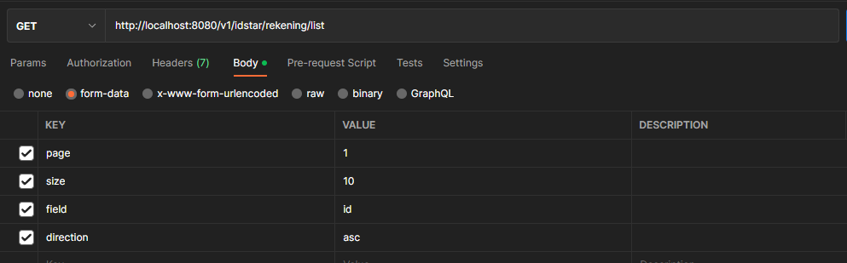

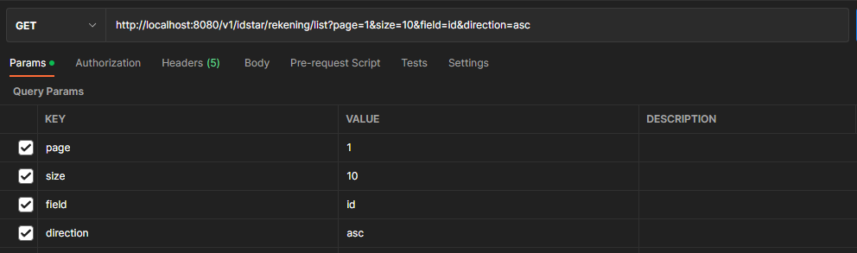

**Sample response:**

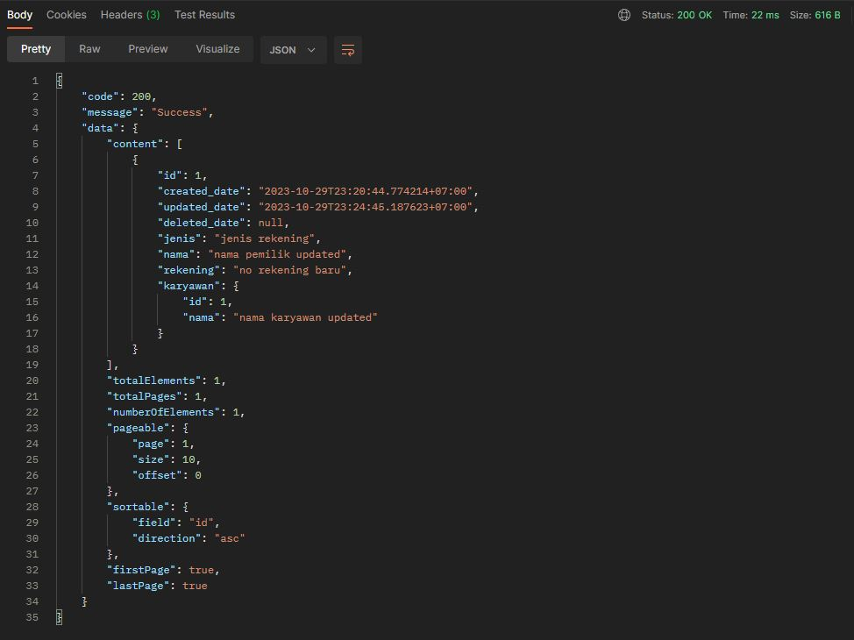

## Get Rekening By ID

Get one **rekening** record by **ID**.

curl -L -g -X GET 'http://localhost:8080/v1/idstar/rekening/{{ID rekening numerik}}'

**Sample request:**

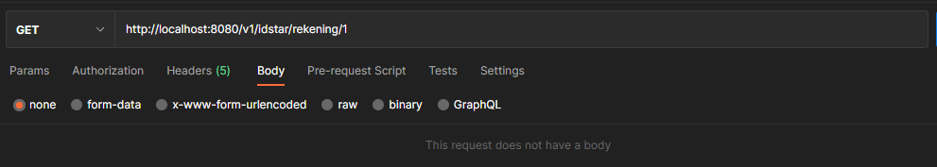

**Sample response:**

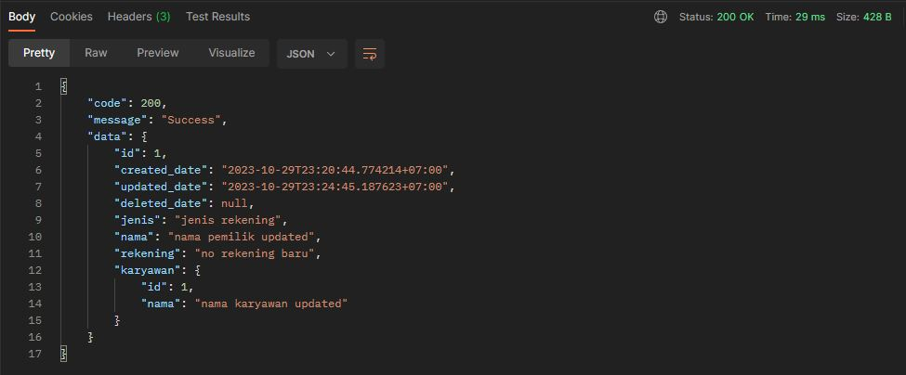

## Delete Rekening

Delete one **rekening** record by **ID**.

curl -L -X DELETE 'http://localhost:8080/v1/idstar/rekening/delete' \

-H 'Content-Type: application/json' \

--data-raw '{

    "id": {{ID rekening numerik}}

}'

**Sample request:**

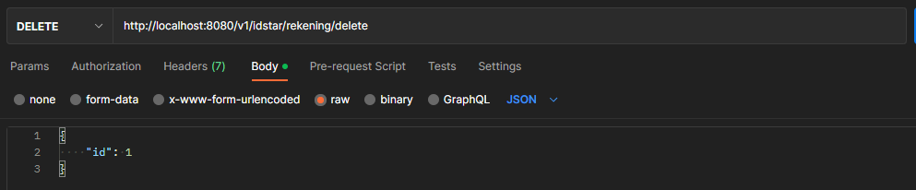

**Sample response:**

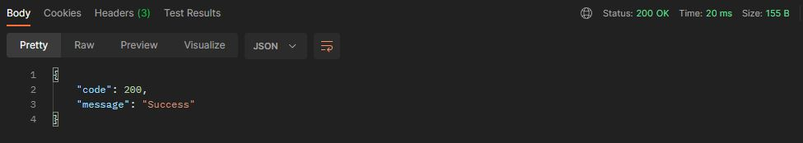

# Training API

## Create Training

Create record of **training** based on request body.

curl -L -X POST 'http://localhost:8080/v1/idstar/training/save' \

-H 'Content-Type: application/json' \

--data-raw '{

    "pengajar": "{{Pengajar training}}",

    "tema": "{{Tema training}}"

}'

**Sample request:**

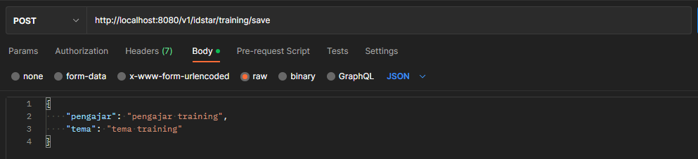

**Sample response:**

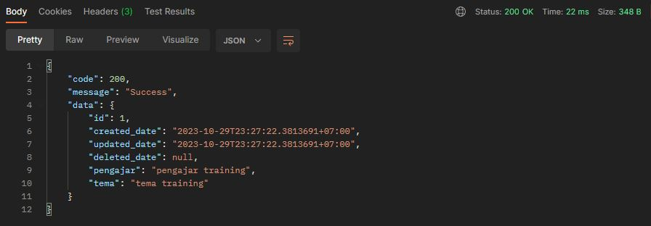

## Update Training

Update record of **training** based on request body.

curl -L -X PUT 'http://localhost:8080/v1/idstar/training/update' \

-H 'Content-Type: application/json' \

--data-raw '{

    "id": {{ID training numerik}},

    "pengajar": "{{Update pengajar training}}",

    "tema": "{{Update tema training}}"

}'

**Sample request:**

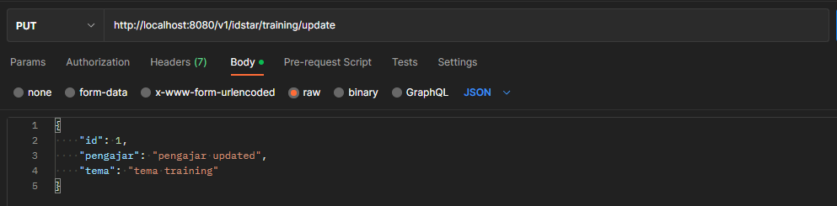

**Sample response:**

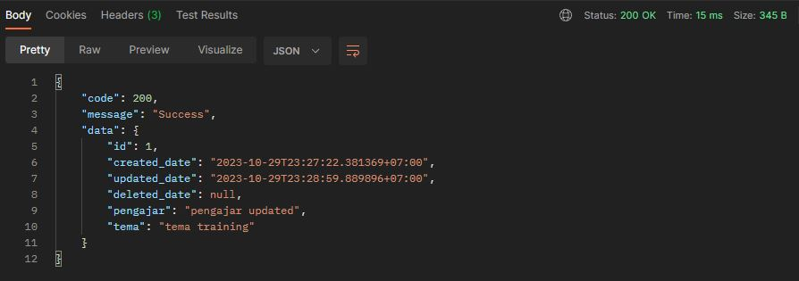

## Get Training List

Get list of **training** with paging and sorting.

Paging and sorting specification can be sent through **form-data** or **query parameter**.

curl -L -X GET 'http://localhost:8080/v1/idstar/training/list' \

-F 'page="{{Nomor paging}}"' \

-F 'size="{{Jumlah record di 1 page}}"' \

-F 'field="{{Field sorting}}"' \

-F 'direction="{{Arah sorting asc/desc}}"'

curl -L -g -X GET 'http://localhost:8080/v1/idstar/training/list?page={{Nomor paging}}&size={{Jumlah record di 1 page}}&field={{Field sorting}}&direction={{Arah sorting asc/desc}}'

**Sample request:**

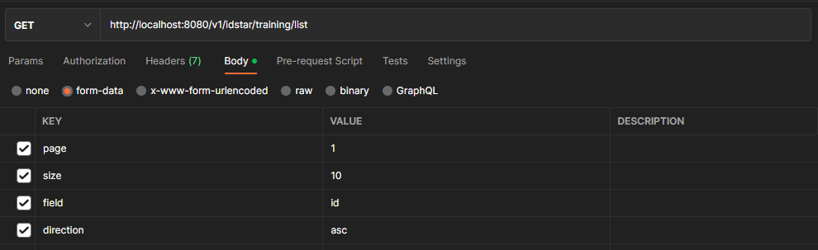

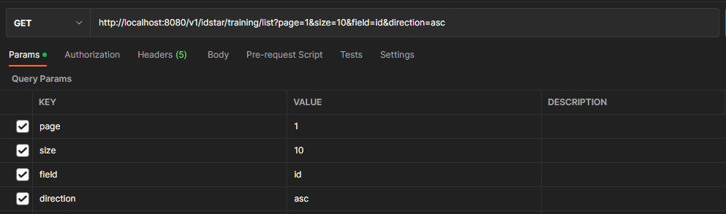

**Sample response:**

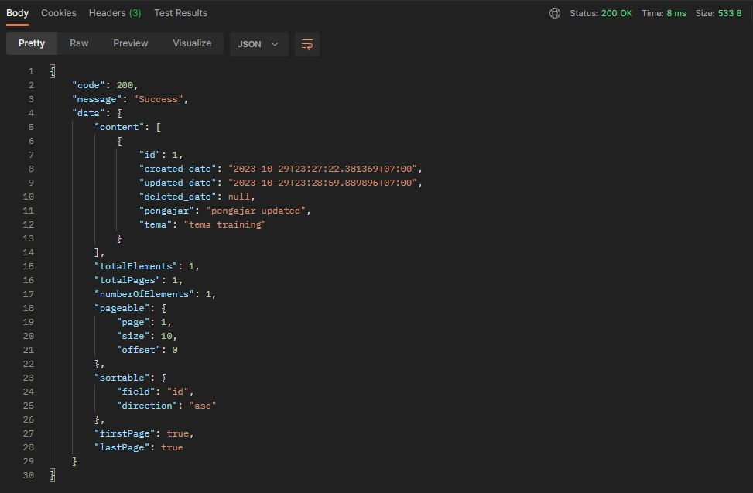

## Get Training By ID

Get one **training** record by **ID**.

curl -L -g -X GET 'http://localhost:8080/v1/idstar/training/{{ID training numerik}}'

**Sample request:**

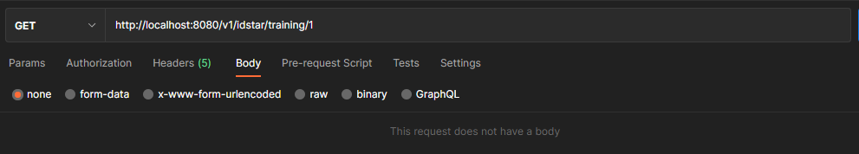

**Sample response:**

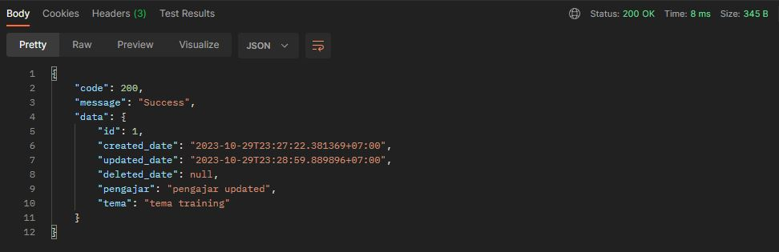

## Delete Training

Delete one **training** record by **ID**.

curl -L -X DELETE 'http://localhost:8080/v1/idstar/training/delete' \

-H 'Content-Type: application/json' \

--data-raw '{

    "id": {{ID training numerik}}

}'

**Sample request:**

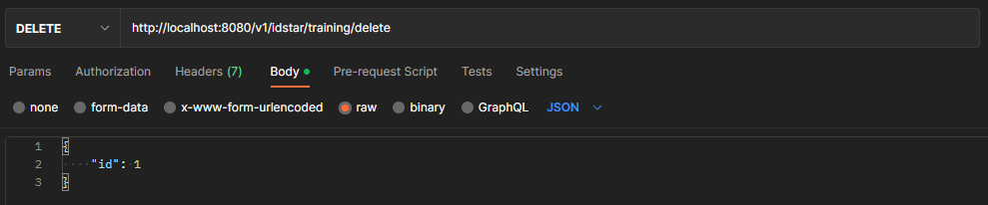

**Sample response:**

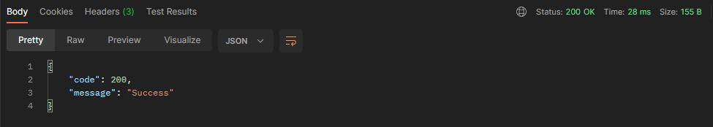

# Training API

## Create Karyawan Training

Create record of **karyawan training** based on request body.

curl -L -X POST 'http://localhost:8080/v1/idstar/karyawan-training/save' \

-H 'Content-Type: application/json' \

--data-raw '{

    "karyawan": {

        "id": {{ID karyawan numerik}}

    },

    "training": {

        "id": {{ID training numerik}}

    },

    "tanggal": "{{Tanggal training YYYY-MM-DD HH24:mm:ss}}"

}'

**Sample request:**

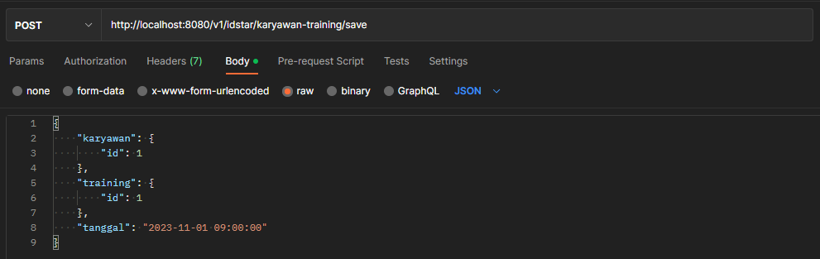

**Sample response:**

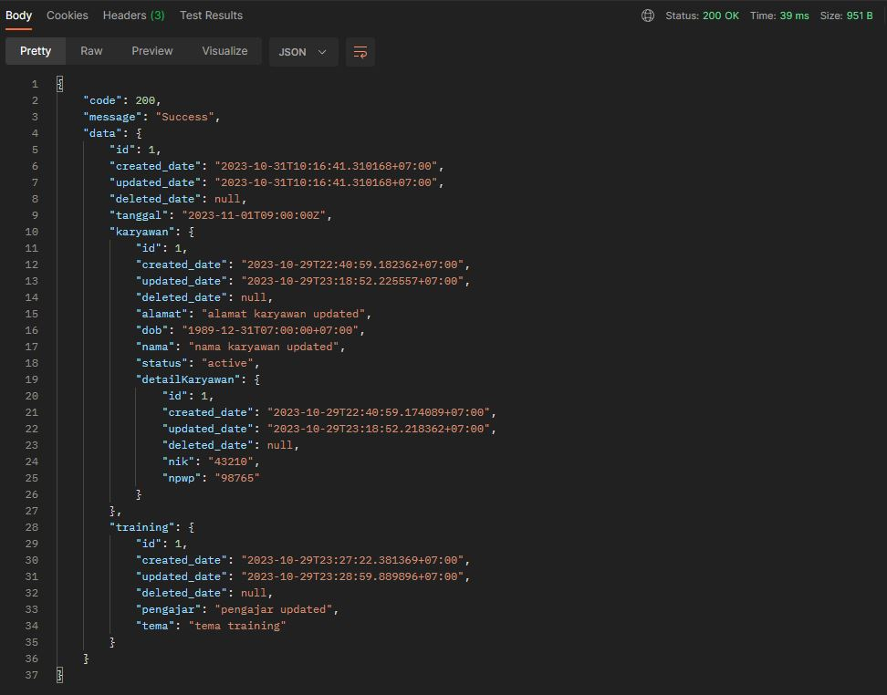

## Update Karyawan Training

Update record of **karyawan training** based on request body.

curl -L -X PUT 'http://localhost:8080/v1/idstar/karyawan-training/update' \

-H 'Content-Type: application/json' \

--data-raw '{

    "id": {{ID karyawan-training numerik}},

    "karyawan": {

        "id": {{ID karyawan numerik}}

    },

    "training": {

        "id": {{ID training numerik}}

    },

    "tanggal": "{{Update tanggal training YYYY-MM-DD HH24:mm:ss}}"

}'

**Sample request:**

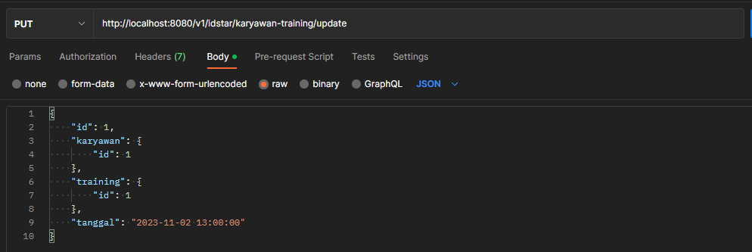

**Sample response:**

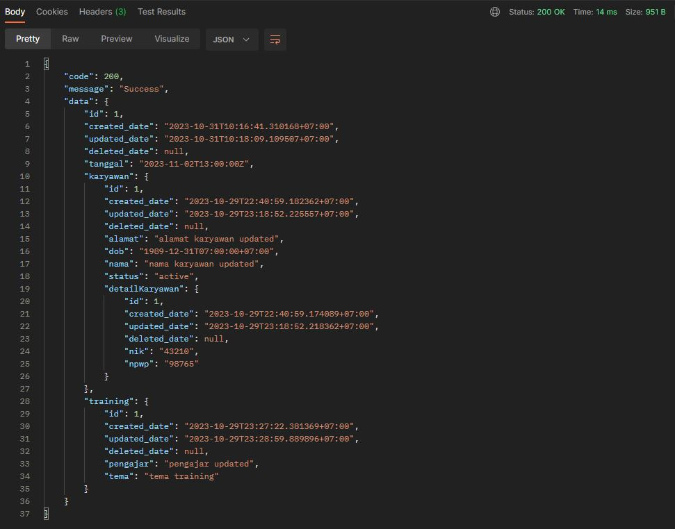

## Get Karyawan Training List

Get list of **karyawan training** with paging and sorting.

Paging and sorting specification can be sent through **form-data** or **query parameter**.

curl -L -X GET 'http://localhost:8080/v1/idstar/karyawan-training/list' \

-F 'page="{{Nomor paging}}"' \

-F 'size="{{Jumlah record di 1 page}}"' \

-F 'field="{{Field sorting}}"' \

-F 'direction="{{Arah sorting asc/desc}}"'

curl -L -g -X GET 'http://localhost:8080/v1/idstar/karyawan-training/list?page={{Nomor paging}}&size={{Jumlah record di 1 page}}&field={{Field sorting}}&direction={{Arah sorting asc/desc}}'

**Sample request:**

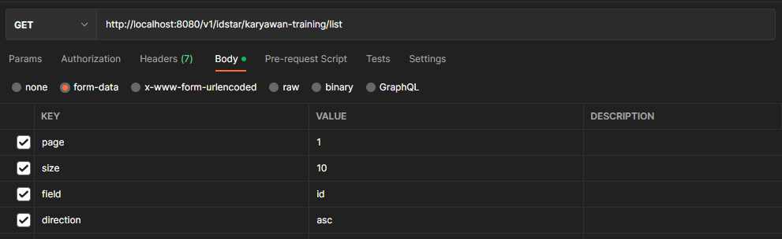

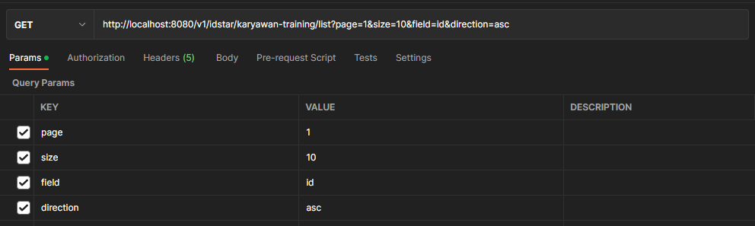

**Sample response:**

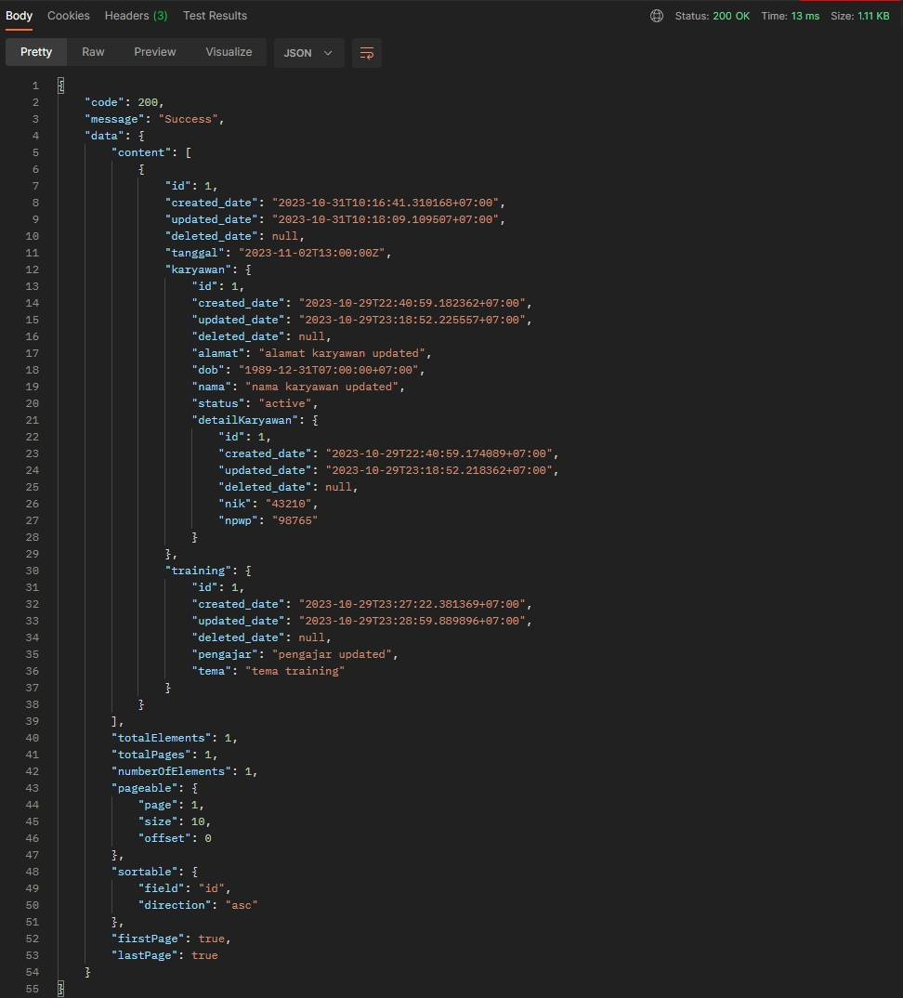

## Get Karyawan Training By ID

Get one **karyawan training** record by **ID**.

curl -L -g -X GET 'http://localhost:8080/v1/idstar/karyawan-training/{{ID karyawan-training numerik}}'

**Sample request:**

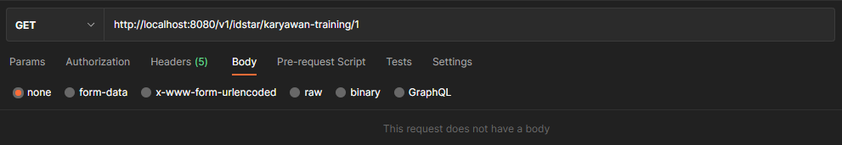

**Sample response:**

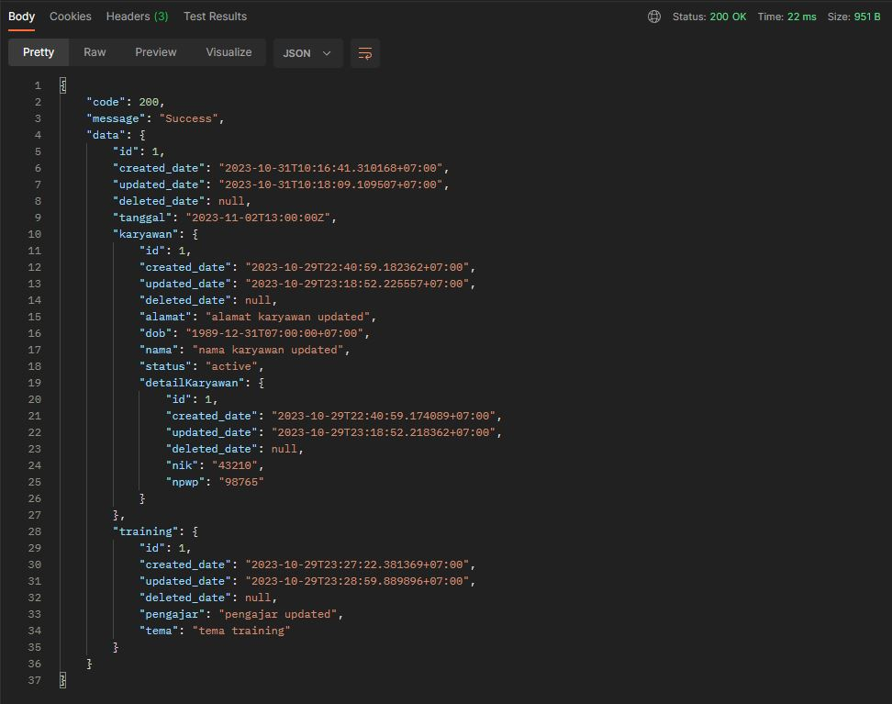

## Delete Karyawan Training

Delete one **karyawan training** record by **ID**.

curl -L -X DELETE 'http://localhost:8080/v1/idstar/karyawan-training/delete' \

-H 'Content-Type: application/json' \

--data-raw '{

    "id": {{ID karyawan-training numerik}}

}'

**Sample request:**

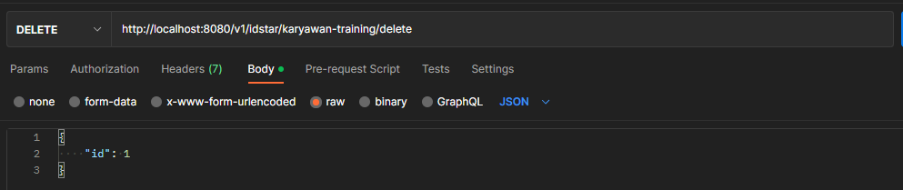

**Sample response:**

